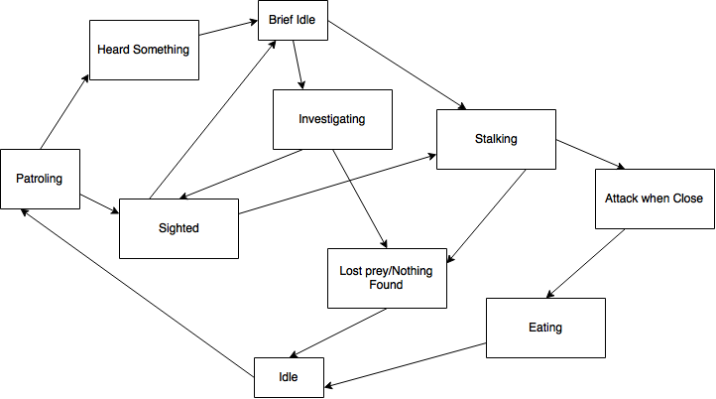

**Patrolling**: Wolf follows his set patrol path searching for prey or anything out of the ordinary.

**Heard Something**: The wolf hears something, halting his movement.

**Brief Idle**: After hearing something the wolf takes a brief pause before going to investigate.

**Investigating**: The wolf heads towards the source of the noise, actively looking for the source.

**Sighted**: The wolf has sighted a rabbit in its line of sight and his attention is now drawn towards it.

**Stalking**: The wolf is now moving towards the rabbit at a slightly slower pace than its normal speed.

**Lost prey/Nothing Found**: The rabbit has escaped the wolf’s line of sight and stayed out of it long enough for the wolf to lose it. If the wolf heard something and could not find anything after searching.

**Idle**: The wolf takes a moment to himself after eating, after losing sight of the rabbit, or after finding nothing during its investigation.

**Attack when Close**: The wolf has gotten close enough to the rabbit that it now attacks.

**Eating**: After catching the rabbit the wolf takes its time eating it.